**Tableau- Assignment 3**

1. Imagine a scenario wherein you wish to display only those “Products” whose “Sales” value ranges from 1000 to 7,000. With the help of tableau filters, create a bar chart visualization, depicting the “Sales” of only those products which lie in this range. Write briefly about your key observations. (Use the PowerStore_USA dataset.)

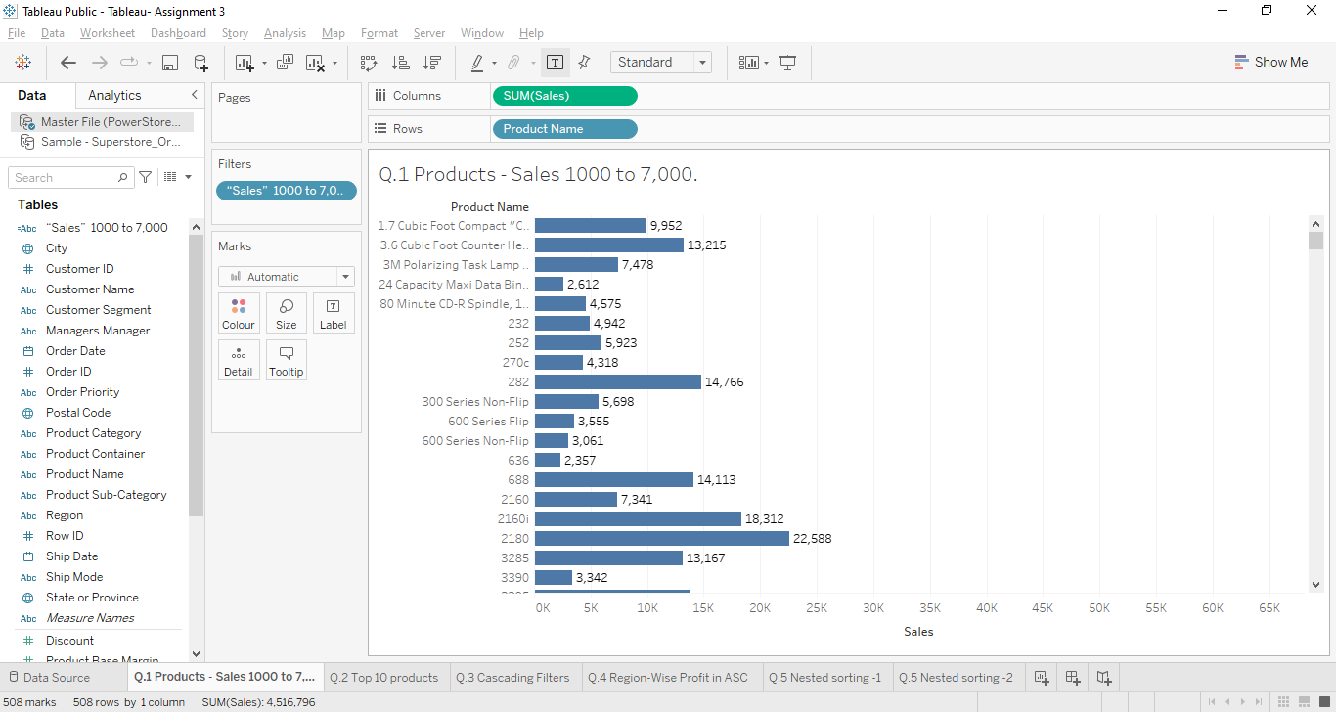

1. Using the “Sample-Superstore.xls” dataset, create a view depicting “Top 10 products” by their “Profits” for “Consumer Segment” with the help of the best-suited visualization for this scenario. (Hint: Consider the visuals that are most appropriate for comparing different categories.)

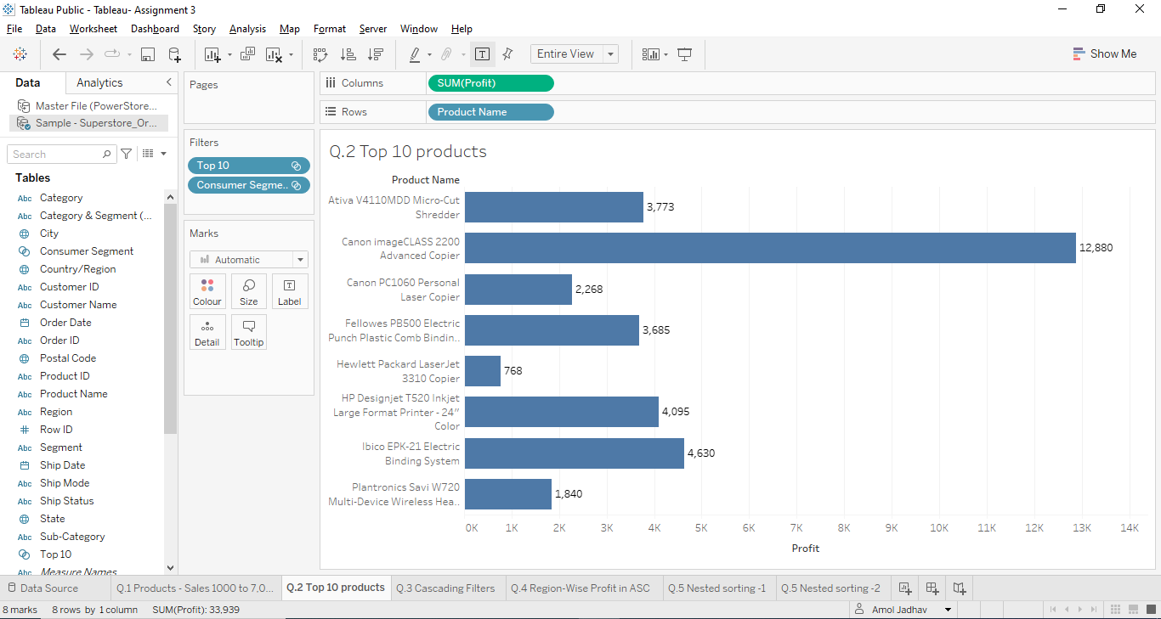

1. When the first filter's selection limits the second filter to only include values that are currently relevant, this is known as cascading (or hierarchical) filtering. Pick up an e-commerce or a provision store data and using the concept of cascading filters, create a bar graph comparing the sales of various regions wherein the “Sub-Category” filter shows all products that are relevant to “Office-Supplies” Category. Notice that there will be a hierarchy of filters on dimensions, one on category and the other one on sub-category.

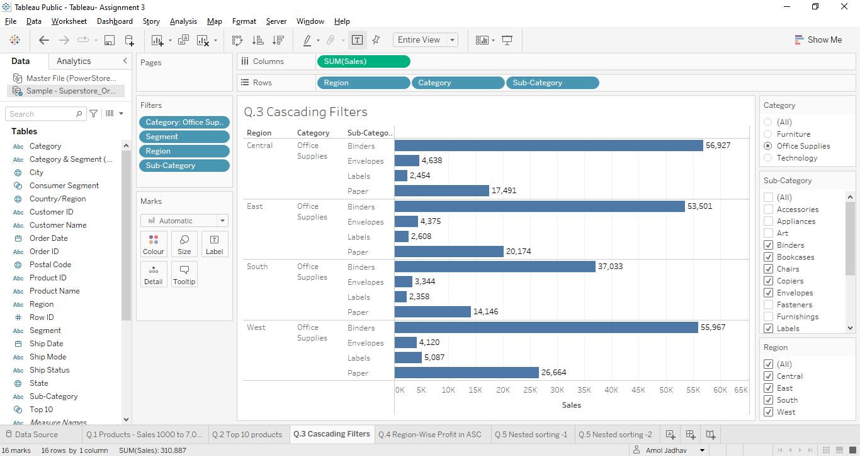

1. Using the “Sample-Superstore.xls” dataset, create a visualization of comparison among different regions based on their average ‘Profit’ in the ascending order.

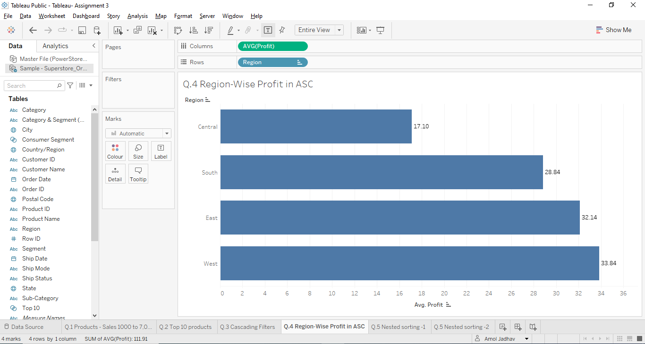

1. Using the concept of nested sorting in Tableau, create a view showing “Category” in ascending order sorted within each “Segment” by the sum of their total “Sales”.

(Use the “Sample-Superstore.xls” dataset.)

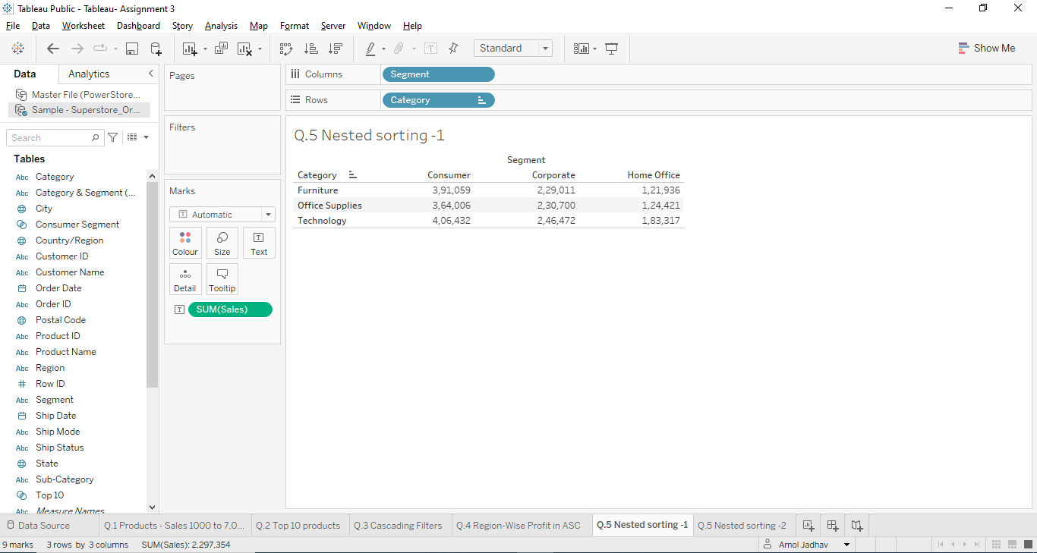

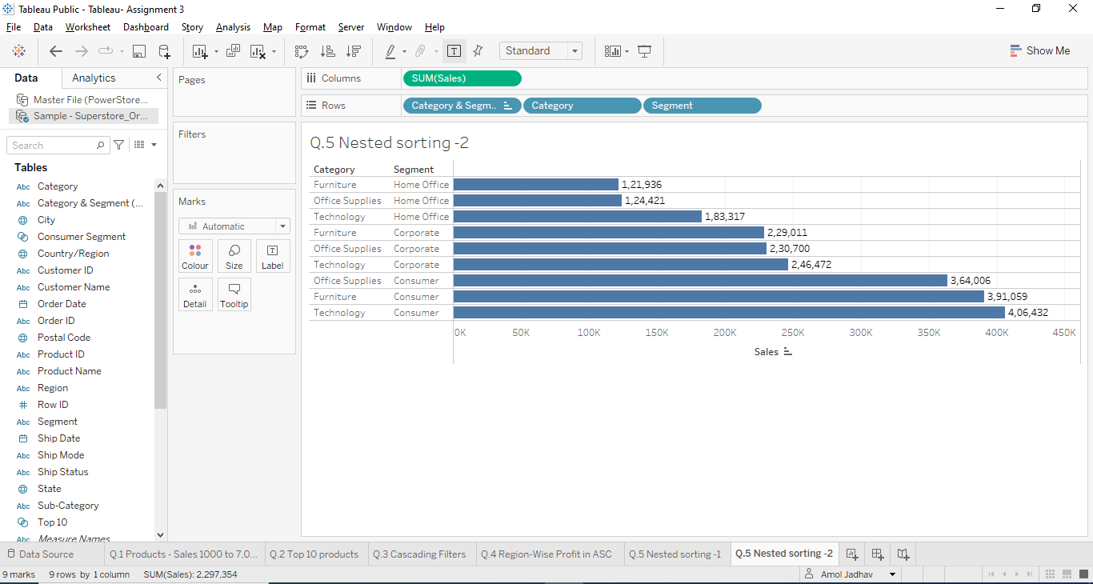

[*PFA links for the datasets used.*](https://drive.google.com/drive/folders/123UyMRbrReCjyn1K4g_FhsjKx6cP4zLH?usp=sharing)